

**TCS Annual Award 2024**

**APPLICATION FORM**

**Award for Basic / Clinical Cytometry**

**Name: Hemavathi Surname: Dhandapani Gender: Female**

**Title (Prof. /Dr./Mr./Ms) Dr. Designation: Scientist II Institution: Thermo Fisher Scientific Address for correspondence: Citius Block, FTP EPIP, Whitefield,**

**Basic**

**Clinical**

**Full Title: In Vitro 3D Spheroid Model Preserves Tumor Microenvironment of Hot and Cold Breast Cancer Subtypes** **Name of the Journal: Advanced Healthcare Material**s **Month and Year of Publication (of acceptance, if not already published): May 2023 List of all authors: Dr. Prakriti Tayalia, Mr. Armaan Siddiqui, Mr. Shivam Karadkar**

**Corresponding Author: Dr. Prakriti Tayalia**  **Institute where this study was carried out: Indian Institute of Technology Bombay Eligibility Details: Are you an Indian citizen (Yes/No): yes**

**Are you a member of TCS (Yes/No): Yes TCS Membership No. S- 1366**

**Signature of the applicant: 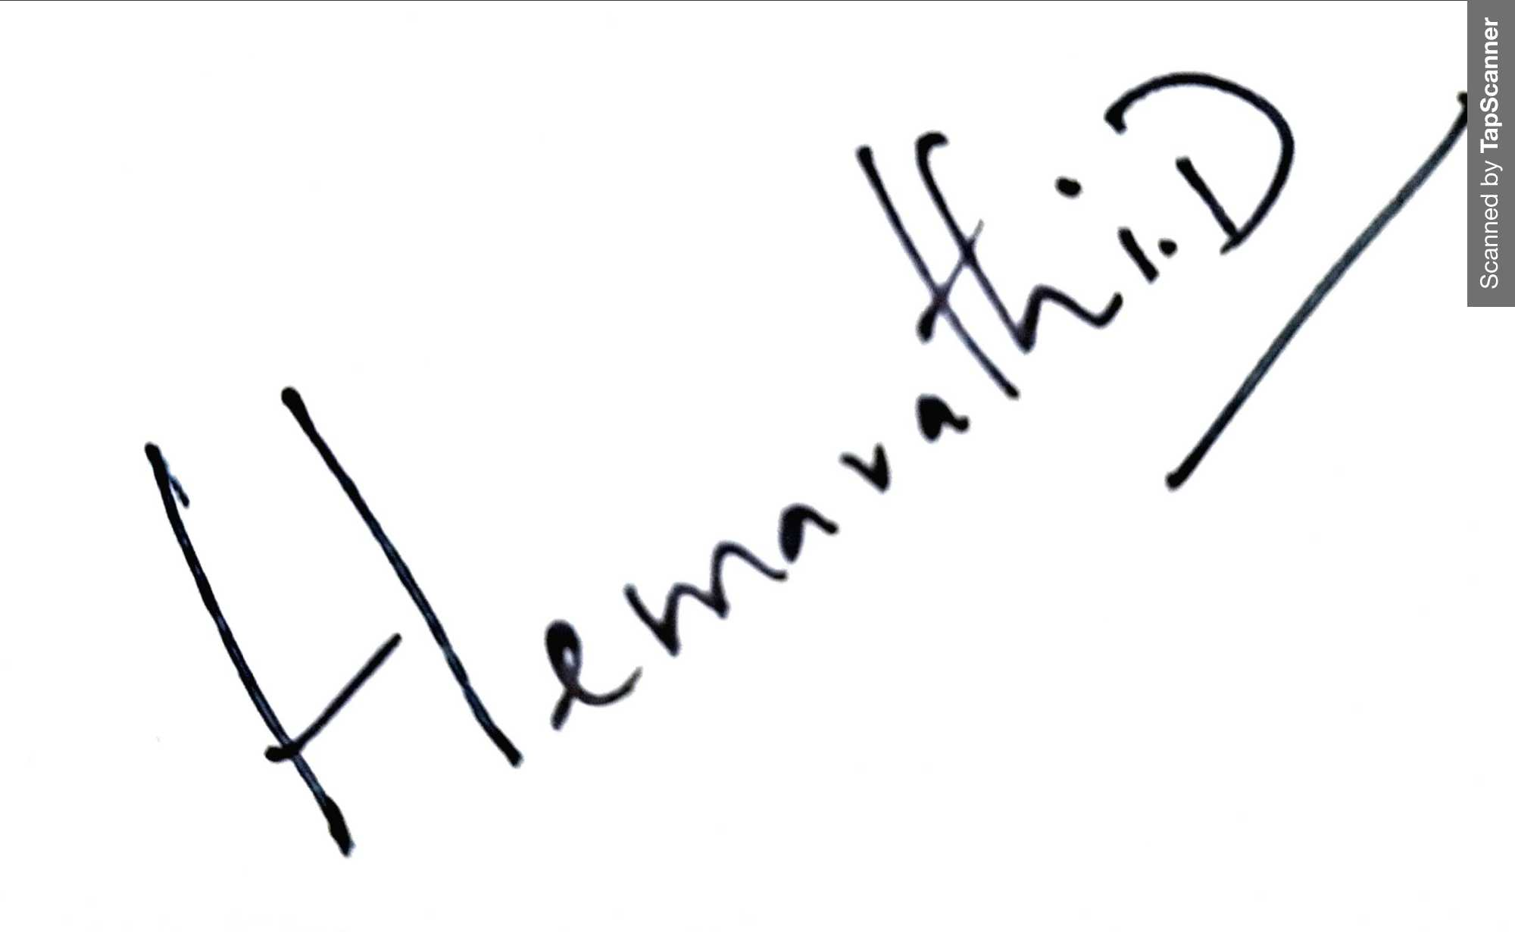 Date of submission 17/08/2024**

**If yes, till which year are the dues paid for: 2024**

**Date of Birth (DD/MM/YYYY): 16th October 1987 I have you read all Terms and Conditions and agree with them (Yes/No): Yes Attachments**

1. **PDF of the manuscript**
2. **Letter of acceptance from the Editor of the Journal (if, not yet published)**
3. **No objection letter from the co-authors in the enclosed format with the name and PAN card number of the award receiving person**

**City: Bangalore Pin code: 560066 Mobile: 9843981087 Email:** [**biohemavathi@gmail.com**](mailto:biohemavathi@gmail.com) **Details of the paper submitted for the award: Award Category: (“X” Mark in the box)**

**TCS Annual Award 2024**

**No Objection Letter from the Co-authors**



This is to confirm that we have no objection to (name of the applicant) **Hemavathi Dhandapani** submitting the paper entitled **In Vitro 3D Spheroid Model Preserves Tumor Microenvironment of Hot and Cold Breast Cancer Subtypes** published in **Advanced Healthcare Material**s for **The Cytometry Society (TCS) award (Basic).** In case of final selection, the cheque bearing the award amount may be presented in favor of the following person (Name in capital letters as in bank account. PAN card number is mandatory):

**Signature of the applicant:** **Date of submission: 17/08/2024**

**Name Hemavathi Dhandapani**

**PAN Card number CMWPD5504J**

**Co-authors:**

**Name Signature Date**

***NOTE: Please add more lines if required. Application form and all its attachments should be submitted latest by 1st September, 2024.***

1 Dr. Prakriti Tayalia 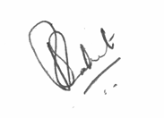15th Aug 2024

2 Mr. Armaan Siddiqui 

12th Aug 2024