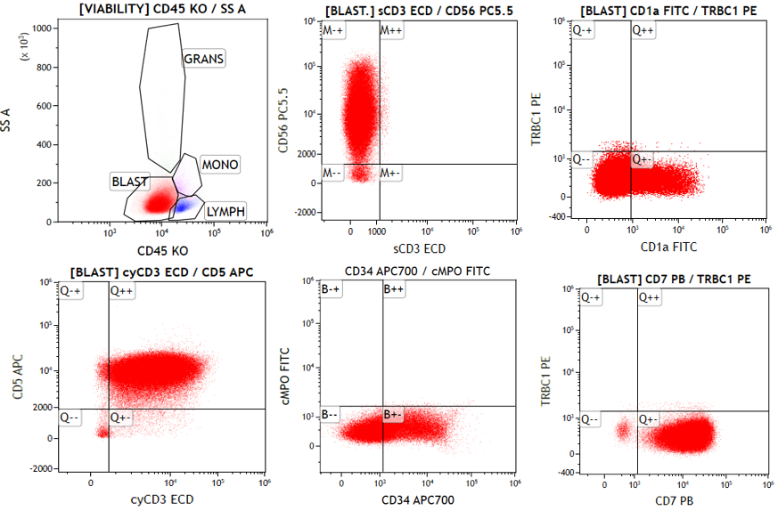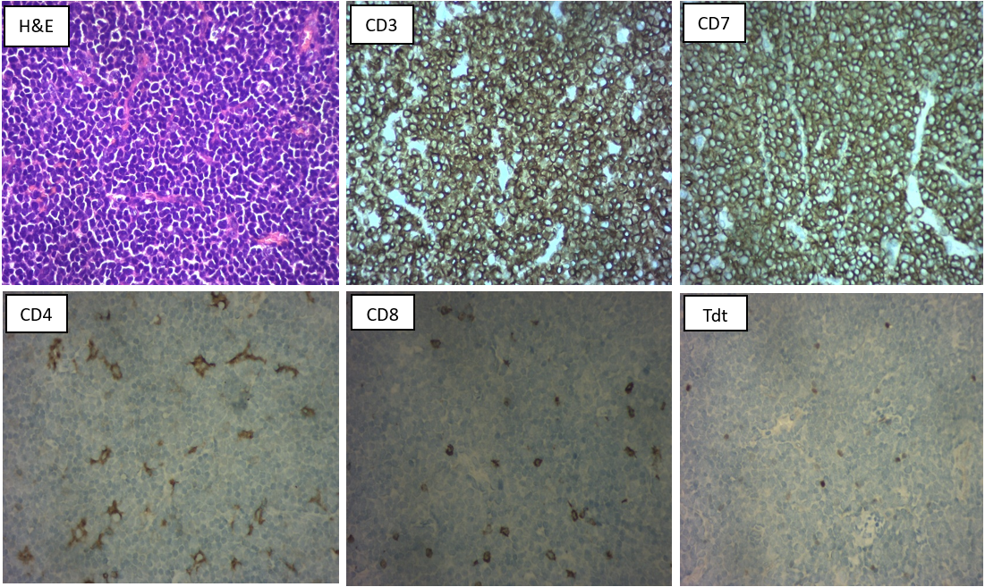

1. Flow plots of the lymph node aspirate ; markers depicted in the x and y axis
2. Figure 1: H&E image of Lymph node biopsy ( 40 X)
3. Fig2 to 6 : Immunohistochemistry images (40 X), markers given in inset